Let’s work together to keep Fiji free from FMD
What is Foot and Mouth Disease (FMD)
Foot and mouth disease (FMD) is a severe and highly contagious viral disease of livestock that has a significant economic impact. Fiji is free from this sever and highly contagious viral disease of animals.
The disease affects cattle, swine, sheep, goats and other cloven-hoofed ruminants. Intensively reared animals are more susceptible to the disease than traditional breeds. The disease is rarely fatal in adult animals, but there is often high mortality in young animals due to myocarditis or, when the dam is infected by the disease, lack of milk.
FMD is characterised by fever and blister-like sores on the tongue and lips, in the mouth, on the teats and between the hooves. The disease causes severe production losses, and while the majority of affected animals recover, the disease often leaves them weakened and debilitated.
The organism which causes FMD is an aphthovirus of the family Picornaviridae. There are seven strains (A, O, C, SAT1, SAT2, SAT3, and Asia1) which are endemic in different countries worldwide. Each strain requires a specific vaccine to provide immunity to a vaccinated animal. All seven of the serotypes have also been found in wildlife.
FMD is found in all excretions and secretions from infected animals. Notably, these animals breathe out a large amount of aerosolised virus, which can infect other animals via the respiratory or oral routes. The virus may be present in milk and semen for up to 4 days before the animal shows clinical signs of disease. The significance of FMD is related to the ease with which the virus can spread through any or all of the following:
- infected animals newly introduced into a herd (carrying virus in their saliva, milk, semen, etc.);
- contaminated pens/buildings or contaminated animal transport vehicles;
- contaminated materials such as hay, feed, water, milk or biologics;
- contaminated clothing, footwear, or equipment;
- virus-infected meat or other contaminated animal products (if fed to animals when raw or improperly cooked);
- infected aerosols (spread of virus from an infected property via air currents).
Animals that have recovered from infection may sometimes carry the virus and initiate new outbreaks of the disease.

Clinical signs
Cattle
- Fever, loss of appetite, shivering, reduction in milk production for 2–3 days, then smacking of the lips, grinding of the teeth, drooling, lameness, stamping or kicking of the feet: caused by vesicles (aphthae) on buccal and nasal mucous membranes and/or between the claws and coronary band o after 24 hours: rupture of vesicles leaving erosions o vesicles can also occur on the mammary glands
- Recovery generally occurs within 8–15 days
- Complications: tongue erosions, superinfection of lesions, hoof deformation, mastitis and permanent impairment of milk production, myocarditis, abortion, permanent loss of weight, and loss of heat control (‘panters’).
- Death of young animals from myocarditis
Sheep and goats
- Fever and oral lesions are often mild
- Foot lesions along the coronary band or interdigital spaces may go unrecognised, as may lesions on the dental pad
- Agalactia in milking sheep and goats is a feature. Death of young stock may occur without clinical signs
Pigs
- Fever
- May develop severe foot lesions and lameness with detachment of the claw horn, particularly when housed on concrete
- Vesicles often occur at pressure points on the limbs, especially along the carpus (‘knuckling’)
- Vesicular lesions on the snout and dry lesions on the tongue may occur. High mortality in piglets is a frequent occurrence
Lesions
- Vesicles or blisters on the tongue, dental pad, gums, cheek, hard and soft palate, lips, nostrils, muzzle, coronary bands, teats, udder, snout of pigs, corium of dewclaws and interdigital spaces
- Erosions on rumen pillars at post mortem. Gray or yellow streaking in the heart from degeneration and necrosis of the myocardium in young animals of all species (‘tiger heart’)
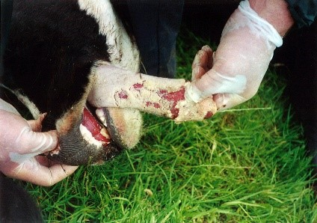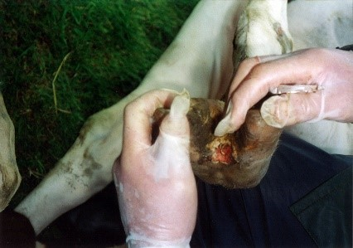
Fig1.1 Pictures of FMD signs in cattle
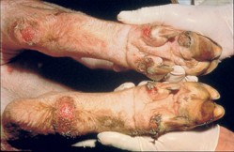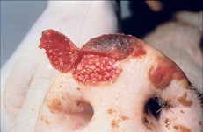
Fig 1.2 Pictures of FMD signs in Pigs
Public health risk
FMD is not readily transmissible to humans and is not a public health risk.
Prevention and control
The initial measures described in the Global Food and Mouth disease control strategy are the presence of early detection and warning systems and the implementation of effective surveillance in accordance with the guidelines detailed World Organization for Animal Health (WOAH).
In general, it is essential for livestock owners and producers to maintain sound biosecurity practices to prevent the introduction and spread of the virus.
Finally, it is mandatory that all the animal and animal products including dairy, dairy products, meat and meat products needs to be declared upon arrival.

For Further Information, Please Contact:
Biosecurity Authority of Fiji on 3312512 or Short Codes:
General Enquiries - 5994, Termites - 5996,
Giant Invasive Iguana (GII) - 5995,
Animal Disease Surveillance - 5997
or email info@baf.com.fj,
visit BAF website www.baf.com.fj

