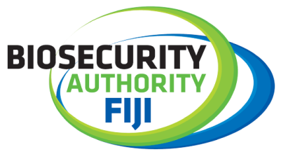

Biosecurity Authority of Fiji supports ‘I don't accept bribes’ campaign
9 February 2022 – The Biosecurity Authority of Fiji (BAF) has joined the ‘I don’t accept bribes’ campaign initiated by the Fiji Independent Commission Against Corruption (FICAC) together with the UN Development Programme (UNDP) under the United Nations Pacific Regional Anti-Corruption (UN_PRAC) project funded by the New Zealand Government.
The launch at the BAF headquarters, together with the badging ceremony was significant as it demonstrates a high – level of commitment from the BAF senior management team in their support in the fight against corruption and making a stand against bribery as a Public Enterprise.
BAF Acting Chief Executive officer, Mr. Surend Pratap while delivering his keynote address highlighted the risks of corruption and the importance of establishing corruption prevention mechanisms at BAF.
“Corruption prevention can reduce the likelihood of its occurrence, and can contain its corrosive effects. But, let us be clear: prevention does not mean printing posters or running television advertisements about the merit of integrity and the cost of dishonesty. Prevention means putting in place concrete anti-corruption measures and public sector management practices based on the rule of law, transparency and accountability,” he said.
Mr. Pratap also highlighted that the awareness trainings facilitated by FICAC will strengthen BAF internal processes.
“Our mandated responsibilities as per the Biosecurity Act 2008 encompass a vast array of areas and as such these areas may also be susceptible to unethical practices. As such, the awareness trainings facilitated by FICAC will strengthen our internal processes, highlight the do’s and don’ts and provide mechanisms and ways to conduct ourselves when faced with challenging situations.”
Meanwhile, FICAC Manager Corruption Prevention, Ms. Kolora Naliva, said that the anti-bribery campaign led by FICAC in Fiji is about bringing long-term systemic governance change, which cannot be achieved without commitment and action of all relevant stakeholders.
“The Biosecurity Authority’s commitment to join this collective journey is very important for at least two reasons:
- To share the message of ensuring that your mandated responsibilities focused on the governance and wellbeing of our people, our environment, our plants and animals, our livelihoods and our unique way of life for the benefit of our families, our visitors and our future generations are based on the values of integrity and are free from any form of corruption,
- As you execute your key roles as custodians to safeguard and protect Fiji’s unique biodiversity and as you deal with and facilitate international trade to and from Fiji, you will be enjoined to do this respecting the values of integrity and anti-corruption.”
The BAF management team is fully committed in supporting FICAC’s mandate in curbing corruption in Fiji.
ENDS…
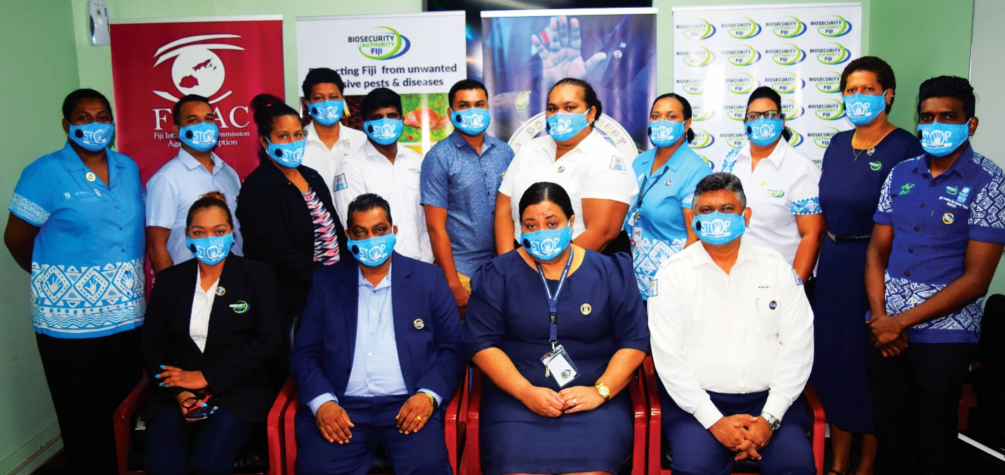
Caption: BAF management team with FICAC representatives during the ‘I don't accept bribes’ campaign launch and badging event at the BAF headquarters.
For more information, please contact,
BAF Communications & Public Relations Executive,
Ashneel Singh
Email: ashneel_s@baf.com.fj
Phone: 9980595
Or visit our website: https://www.baf.com.fj/

