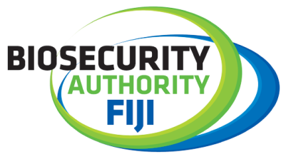

Partnership with DHI – Vessel Check to strengthen BAF monitoring process
The Biosecurity Authority of Fiji (BAF) recently signed a Memorandum of Agreement (MOA) with DHI – Vessel Check to strengthen BAF monitoring process.
Vessel-Check is a decision support tool for both vessel managers and biosecurity authorities providing a global solution for vessel-related biosecurity management. The portal focusses on the management practices employed by a vessel to manage its biosecurity risks. Vessel-Check applies a consistent and transparent methodology to understand if the strategies employed by the vessel are sufficient to mitigate the transfer of invasive aquatic species (IAS).
Invasive marine pests, often introduced to the environment through vessels, are a major biosecurity threat to maritime industries. As it is difficult to respond to this risk promptly, vessel managers and authorities are being hit with substantial costs to eradicate these pests after they have infiltrated a marine environment.
BAF Acting Chief Executive Officer, Mr. Surend Pratap said that BAF was pleased to adopt Vessel-Check as its national Aquatic Biosecurity solution in order to reduce the risk of spread of Invasive Marine Species (IMS). Fiji is an archipelago of more than 300 islands, and has one of the most pristine marine environments on earth. It’s famed for palm-lined beaches and coral reefs with clear lagoons.
“The mission of the Biosecurity Authority of Fiji is to protect Fiji’s unique and precious biodiversity and facilitate international trade to and from Fiji. We work to protect people, our environment, our plants and animals, our livelihoods and our unique way of life for the benefit of our families, our visitors and our future generations. Tourism is a particularly essential industry to the Fijian economy, as it employs more than 40,000 people either directly or indirectly. A pristine marine environment that is not negatively impacted by Invasive Marine Species is essential for tourism. We are pleased to partner with Vessel-Check in order to reduce the risk to our marine environment,” he said.
Vessel-Check completely transforms the way aquatic biosecurity risks are being assessed in line with IMO guidelines. The cloud-based portal prevents invasion of marine pests by providing near real-time information of potential risks. With this globally centralised ‘point of truth’ for all aquatic biosecurity information, regulators—as well as vessel operators and owners—benefit from improved decision-making, efficient resource allocation and more accurate and secure information sharing.
Vessel-Check assesses whether a vessel’s aquatic biosecurity management is sufficient to mitigate the transfer of invasive marine species to as low as reasonably practicable. Vessel arrival data is updated frequently, providing an up-to-date forecast of the potential aquatic biosecurity risk for vessels entering your jurisdiction. The portal can be used easily by anyone in the marine industry: regulators, vessel operators/owners and service providers – no special expertise is needed. Store all relevant vessel aquatic biosecurity information within the portal, allowing; sharing and re-use of information across stakeholders, easy transmission/download when needed (i.e. Biofouling Record Book, Biofouling Management Plan, Biofouling Risk Assessment Summary Report, Antifouling Coating Certificates, Relevant Documentation etc.)
ENDS…

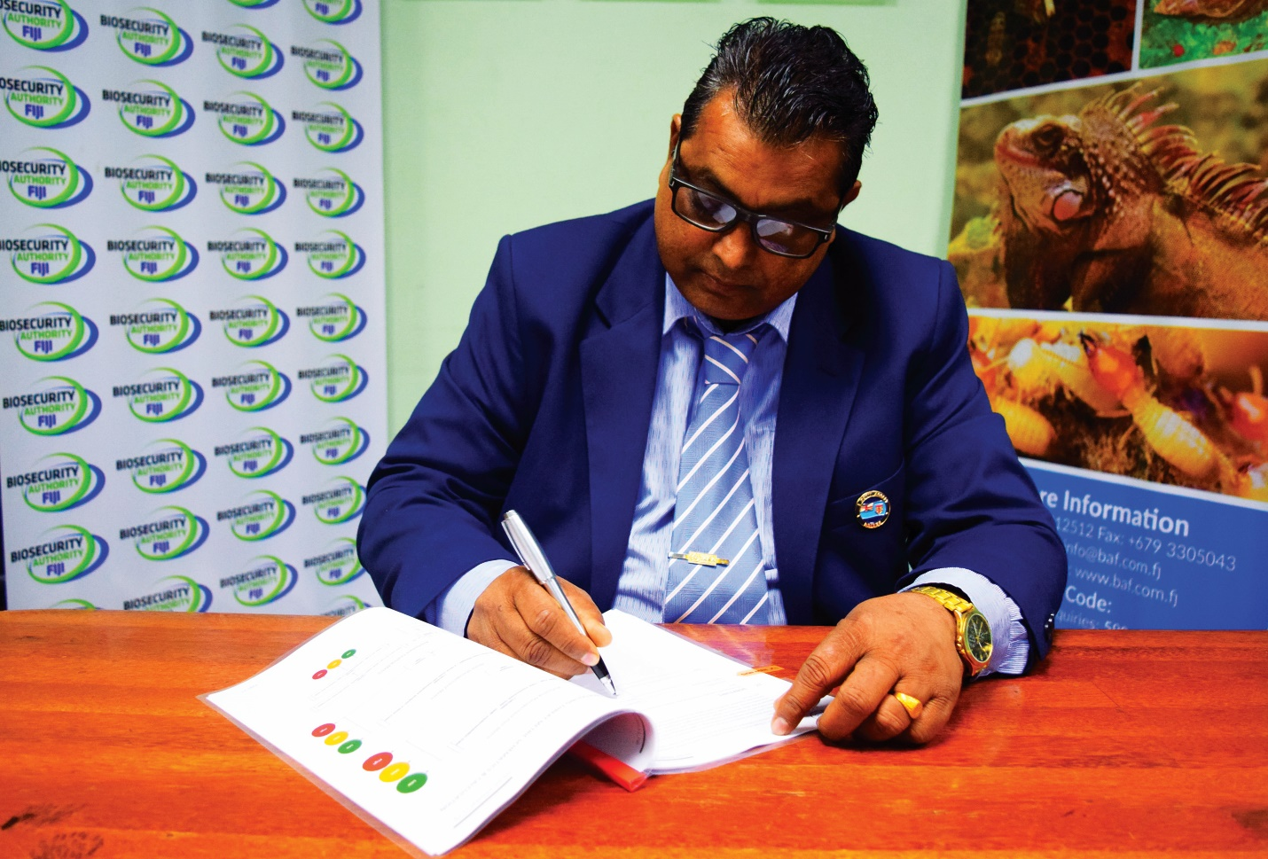

Caption: BAF Acting Chief Executive Officer, Mr. Surend Pratap while signing the Memorandum of Agreement (MOA) with DHI – Vessel Check
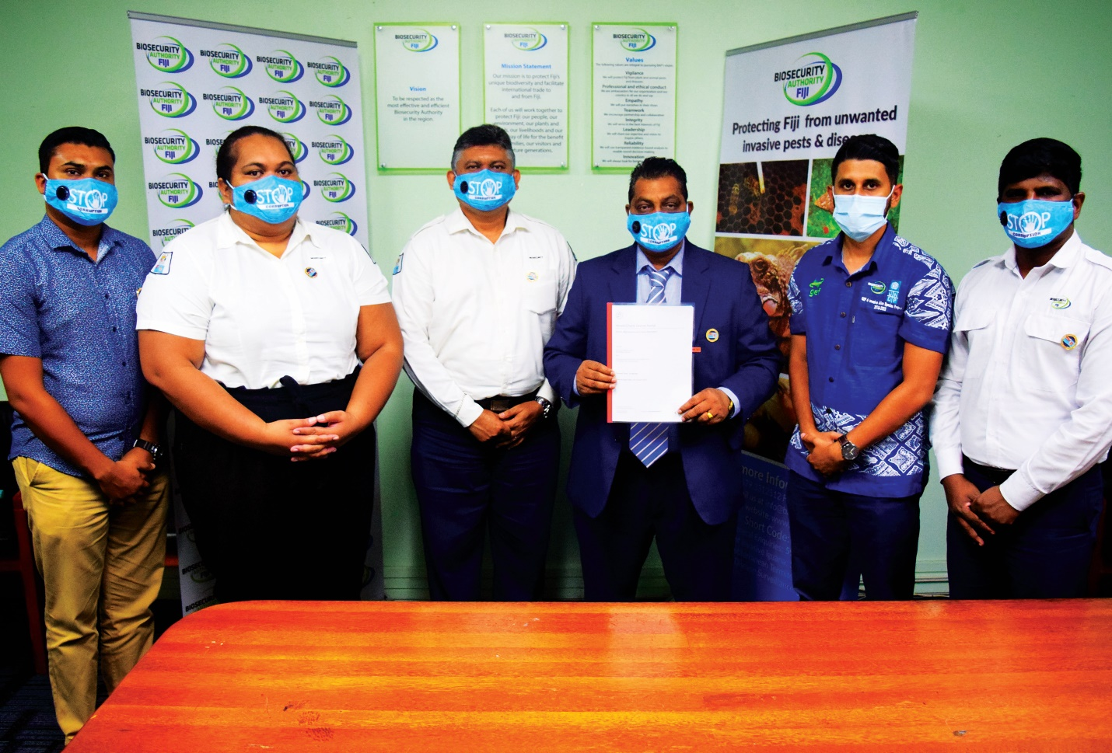
Caption: Group shot of BAF team after signing the MOA.

