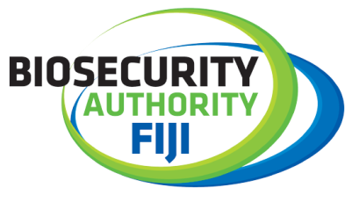
Call for greater partnership between agencies and communities to protect Fiji borders
18 February 2022 – “There is a need for a greater partnership between the border agencies, and the communities to protect the Fiji borders”, was the collective message received from the villages covered during the first week of coastal awareness programme held from the 14 – 18 January.
The Biosecurity Authority of Fiji (BAF) in collaboration with the Fiji Revenue Customs Services (FRCS), the Invasive Alien Species (IAS) Project and other agencies (iTaukei Affairs Board, Nature Fiji - MareqetiViti, Fiji Navy and The Fiji Police Force) conducted the first week of the awareness sessions in the Cakaudrove province.
Villages covered during the first week included Yasawa, Nagasauva, Tawake, Wainigadru, Korotasere, Nailou, Karoko, Vunikura, Loa, Sese, Naboutini, Saqani, Lakeba, Buca, Tukavesi, Koroivonu, Kanakana, Dakuniba, and Nawi.
The respective agencies took time to create awareness and outreach amongst communities and to alleviate knowledge regarding their operations and activities. Some of the key areas highlighted during the presentation and discussion facilitated by the agencies included (and not limited too), impact of illegal trade and smuggling, introduction of the Invasive Alien Species (IAS), and the need to protect our endemic and native species.
Village participants collectively agreed that there is a need for joint collaboration between the agencies and the communities to safe guard and protect our borders. There were also discussions on ways to secure and conserve our biodiversity, endangered species through continuous awareness, education and collaboration.
Through the GEF 6 funded project together with UNDP and assistance from the Government of Fiji, the main agenda is to improve the chances for long-term survival of terrestrial endemic and threatened species on Taveuni Island, surrounding islets and throughout Fiji by building national and local capacities to manage IAS.

The outcomes encompass: strengthening IAS policy, institutions and coordination at the national level to reduce the risk of IAS entering Fiji; improving IAS prevention and surveillance operations at the island level on Taveuni, Qamea, Matagi and Laucala; Long-term measures for protection of terrestrial ecosystems and their biodiversity in the selected islands; and strengthening awareness, knowledge management, monitoring and evaluation in regards to invasive alien species and biosecurity.
Each village headman received surveillance kits that included torches, binoculars, recording sheets that can be used to keep a lookout for incursion of invasive alien species, illegal activities, trade happening at their respective borders, while the participants during the sessions received giveaways such as umbrellas, caps, pens and bags.
ENDS…
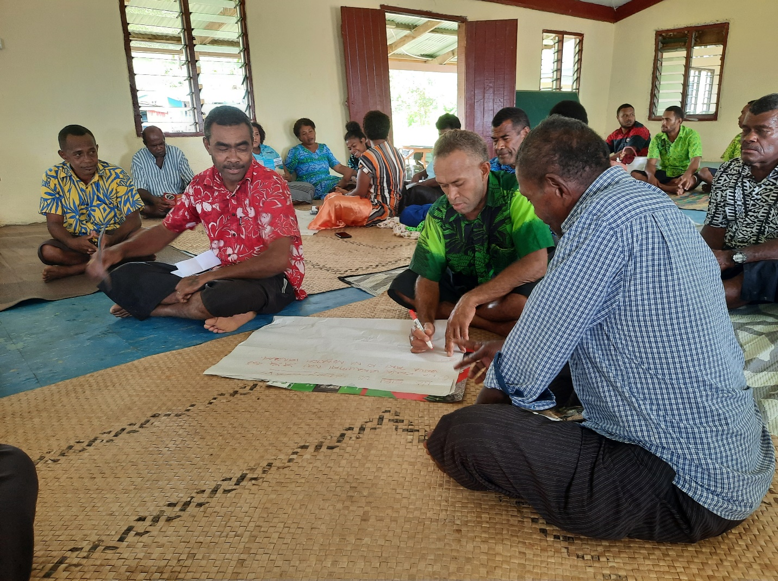
Caption: Participant of Saqana village in the province of Cakaudrove during group discussions.
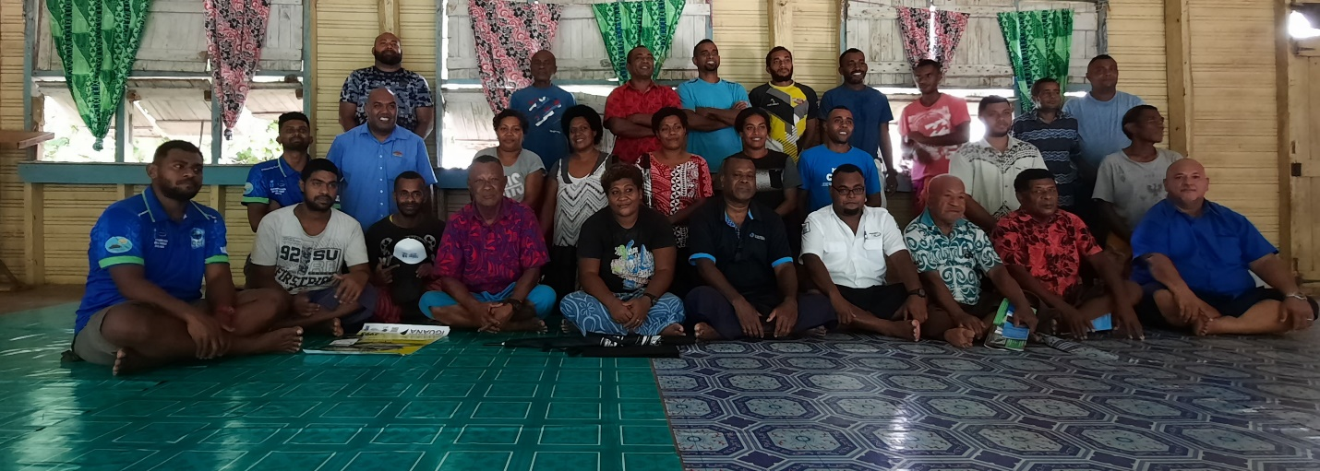
Caption: Group photo of respective agencies and participants of Naboutini village in the Cakuadrove province.
For more information, please contact,
BAF Communications & Public Relations Executive,
Ashneel Singh
Email: ashneel_s@baf.com.fj
Phone: 9980595
Or visit our website: https://www.baf.com.fj/

