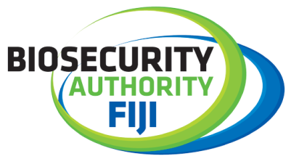
Coastal awareness watch to create extensive awareness in protecting Fiji borders
10 February 2022 – The Biosecurity Authority of Fiji (BAF) in collaboration with the Fiji Revenue Customs Service (FRCS), the Invasive Alien Species (IAS) Project and other agencies (iTaukei Affairs Board, Nature Fiji, Fiji Navy and The Fiji Police Force) will embark on a three – week coastal awareness watch programme in selected coastal settlements in Vanua Levu, Savusavu and Taveuni from the 14 February – 5 March, 2022.
The coastal watch programme will allow agencies to create awareness and outreach amongst communities particularly in the areas where Fijians have difficulty in accessing vital information. As such this programme will allow the agencies the much needed opportunity to alleviate knowledge regarding their operations and activities.
This outreach program will eliminate gaps leading to a more knowledge based society. This is a proactive, collaborative and coordinated approach taken by the agencies regarding matters of concern to our communities.
BAF and the United Nations Development Programme (UNDP) are co-implementers of the Global Environment Facility (GEF) 6 Invasive Alien Species (“IAS”) Project titled ‘Building Capacities to Address Invasive Alien Species to Enhance the Chances of Long term Survival of Terrestrial Endemic and Threatened Species on Taveuni Island, Surrounding Islets and Throughout Fiji Project’ (“GEF 6 Project”) and has embarked on a 5 year programme to eradicate the Green Invasive Iguana (“GII”) from Qamea, Matagi, Laucala and Taveuni Islands.
The Coastal Watch Programme is a result of the GEF 6 IAS Project objective to strengthen linkages with stakeholders, especially in border control to prevent the introduction of alien species into Fiji. Hence BAF, through the GEF 6 project, is taking steps to foster partnerships between Fiji Revenue Customs Service (“FRCS”) and other stakeholders to keep unwanted organisms away from Fiji and to empower Fijian communities in the maritime zones of Fiji as the first step to protecting our shores.

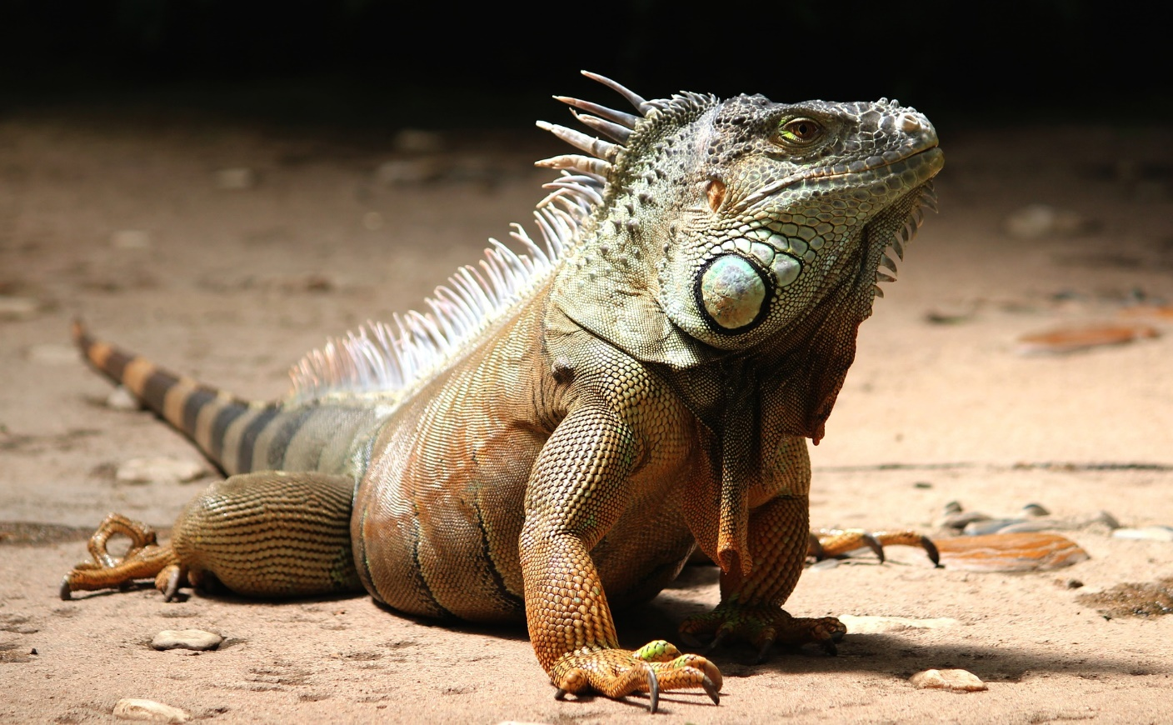
Caption: Green Invasive Iguana (GII)
ENDS…

For more information, please contact,
BAF Communications & Public Relations Executive,
Ashneel Singh
Email: ashneel_s@baf.com.fj
Phone: 9980595
Or visit our website: https://www.baf.com.fj/

