PRESS RELEASE

FIJI GEF 6 UNDP INVASIVE ALIEN SPECIES PROJECT - BAF UNDERTAKES CONSULTATIVE WORKSHOP WITH KEY STAKEHOLDERS IN PREPARATION FOR THE MID TERM REVIEW

The Biosecurity Authority of Fiji (BAF) in collaboration with the United Nations Development Programme (UNDP) launched a week-long consultative workshop, in Nadi from the 08 to 12 of March 2021 on the Fiji Invasive Alien Species (IAS) Project ahead of the project’s mid-term review requirements taking place this year.

This is part of the ongoing Global Environment Facility (GEF) 6 funded project called “Building Capacities to Address Invasive Alien Species to Enhance the Chances of Long-term Survival of Terrestrial Endemic and Threatened Species on Taveuni Island, Surrounding Islets and Throughout Fiji” (GEF Project). The GEF project was officially endorsed in May 2018.

As part of the ongoing project, BAF along with its key stakeholders and the Government’s aim to improve the chances of long-term survival of terrestrial, endemic and threatened species on Taveuni Island, including its surrounding islets and throughout Fiji by building national and local capacities to manage IAS.

Background regarding IAS

The IAS is amongst the greatest threat to every countries biodiversity in the Pacific Islands region with Fiji being no exception. Numerous IAS have been introduced into Fiji over the years which have had a significant impact on our natural landscape and biodiversity.
The introduction of the Giant Invasive Iguana – GII (Iguana iguana) – to Fiji represents the first established population of this species in the Pacific and is a potential bridgehead to some of the world’s most isolated island ecosystems. The GIIs have already caused harm throughout the Caribbean where they are spreading fast and have significant detrimental effects, including on native biodiversity, agriculture and tourism.

Hence, the need to work collaboratively in eradicating the GII and other IAS from Fiji.

The week-long workshop focused on the evaluation of deliverables for the project, preparing timelines for the second half of the project, updating the 2021 annual work plan and forging greater collaboration with key stakeholders to enhance efforts towards the GEF project in eradicating the Giant Invasive Iguana (GII) and creating awareness for other IAS present in Fiji.

The workshop provided a great platform for discussions on IAS, how to best manage and address IAS, review of policies and legislation in IAS, and roles of Government Ministries and statutory bodies including BAF in executing needed activities on time. Additionally, the stakeholders also held planning sessions for the recently launched 2021 FRCS Joint Coastal Watch Programme targeting the vulnerable Lau Group for its first maritime awareness campaign to empower communities in the maritime islands.

It was also an opportune time to discuss and look at ways of improving border control – IAS prevention and surveillance in Taveuni, Qamea, Laucala and Matagi. Panel discussions also took place during the week which allowed stakeholders to ponder on the roles of agencies and their experiences to date and the way forward for addressing IAS in Fiji.

The key stakeholders attending the workshop include personnel from UNDP, UNODC, Ministry of Waterways and Environment, Ministry of Agriculture, Ministry of Forestry, Ministry of iTaukei Affairs, iTaukei Affairs Board, Ministry of Defence, Fiji Police Force, Fiji Revenue and Customs Services, and Fiji Airports Ltd, Nature Fiji Mareqeti Viti, University of the South Pacific, Fiji National University, Conservation International, Birdlife, National Trust of Fiji, Pacific Community, Fiji Ports Cooperation Limited, Fiji Environmental Law Association and Mamanuca Environment Society.
The workshop concluded on Friday 12 March 2021.
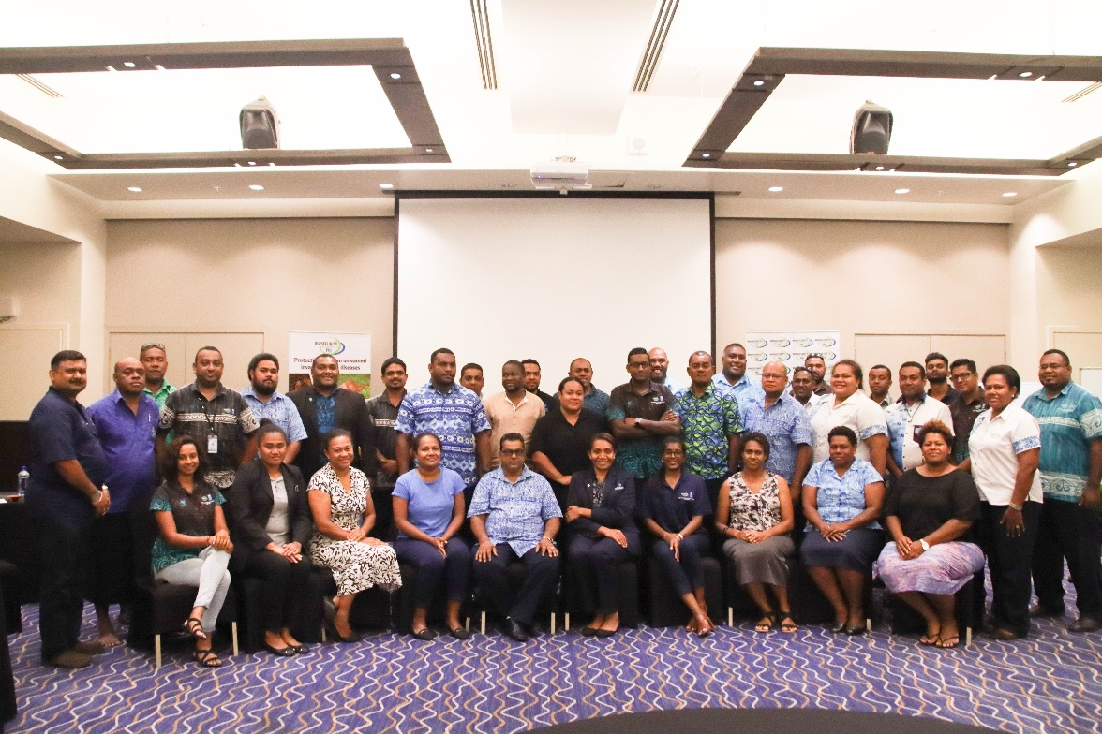
Group picture of the Participants during the consultative workshop with key stakeholders in preparation for the midterm review
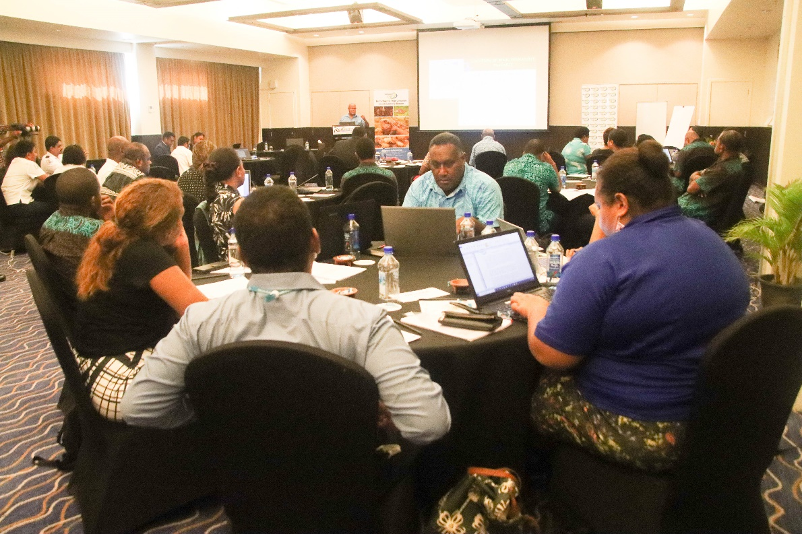
Participants during the workshop discussing on key issues surrounding IAS in Fiji
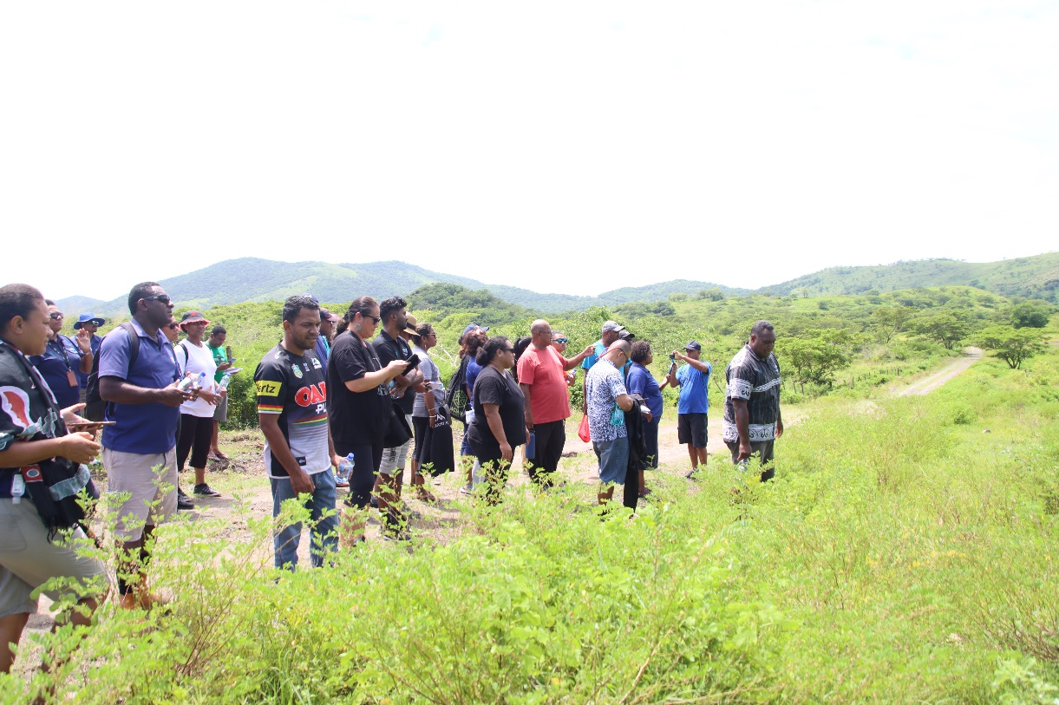
GEF 6 IAS Stakeholders field trip to Vatia, Tavua to visit the last site of dry forest.

